Report Sheet

Appusbwall2 and appusbwal21

- 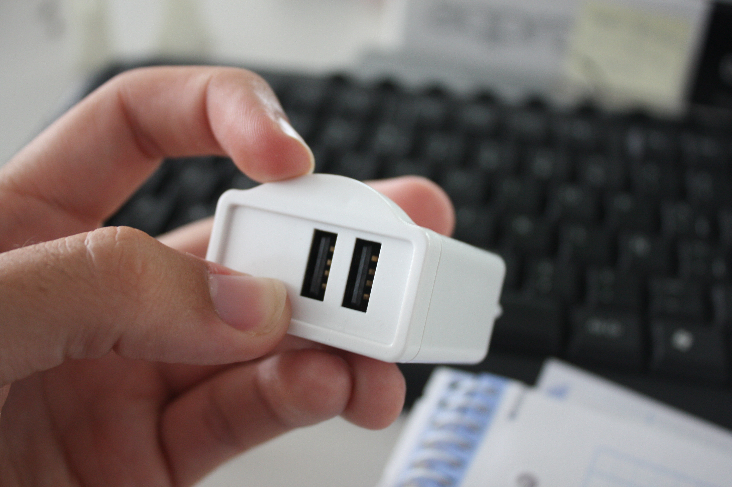Please, improve this mark injection in the curve frontal it is not beautiful this mark in the frontal of product. Please improve this aspect because the slick printing logo is in this place.

Look:

- Remember the frontal sticker, the slip rubber are not necessary finally.

